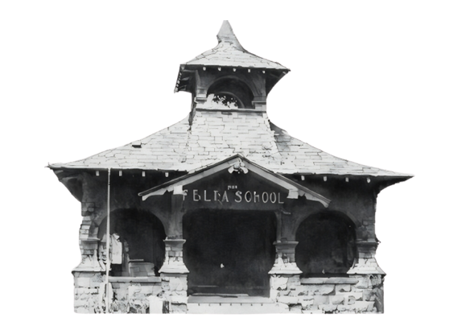
Jogathon | October , 2025
A fundraiser to support West Side School

Felta Education Foundation
1201 Felta Road / Healdsburg, CA 95448
Tax ID 68-0479413

*Please make all donations & checks to the
Felta Education Foundation

SPONSOR INFORMATION:

Legal Donor (company or individual, as appropriate)

Contact Name(First & Last)

Address |  | City | State | Zip Code
Telephone E-mail

Whom should we contact with questions? (Name, phone# and/ or e-mail)

All donations are tax-deductible. We will send you an acknowledgment to the address above for tax purposes. If you wish this letter to be sent to a different person/ address, please make a note below.

